1. 從<https://offensive-security.com/pwkfiles/scans.tar.gz> 下載掃瞄結果檔案

wget <https://offensive-security.com/pwkfiles/scans.tar.gz>

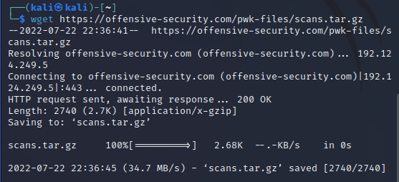

2. 解壓縮並比對掃描結果有何不同

tar -zxvf scans.tar.gz

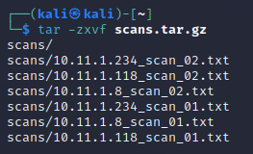

vimdiff scans/10.11.1.234_scan_01.txt scans/10.11.1.234_scan_02.txt

